Research Internship Results:

1. GROUND STATE:

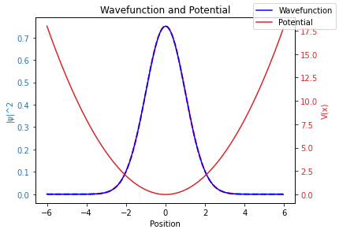

1. FIRST EXCITED STATE:

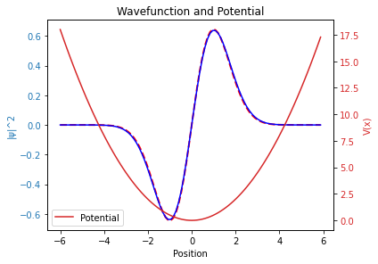

1. SECOND EXCITED STATE:

